* **BREAKING**



Red Sox 10, Braves 7, 9th inning

**Community college sports an**

**endangered but essential species**

**By Zolan Kanno-Youngs** Globe Correspondent, July 6, 2015, 6:02 p.m.



|  |  |  |  |  |  |  |
| --- | --- | --- | --- | --- | --- | --- |
|  | Commeerrcciiaall Grraadee Adheessiivvee TTaabss (P...  $9.99 | Small Sha…  $110.50 | Stacckked…  $191.76 | Sample P…  $24.99 | Larrgee Sh…  $269.19 | Kiwii Sllaass…  $95.88 |
| Blue Gra…  $339.40 | Shaded…  $169.74 | Warrm Sh…  $169.74 | Cayymaan…  $95.88 | Warrm O…  $191.76 |

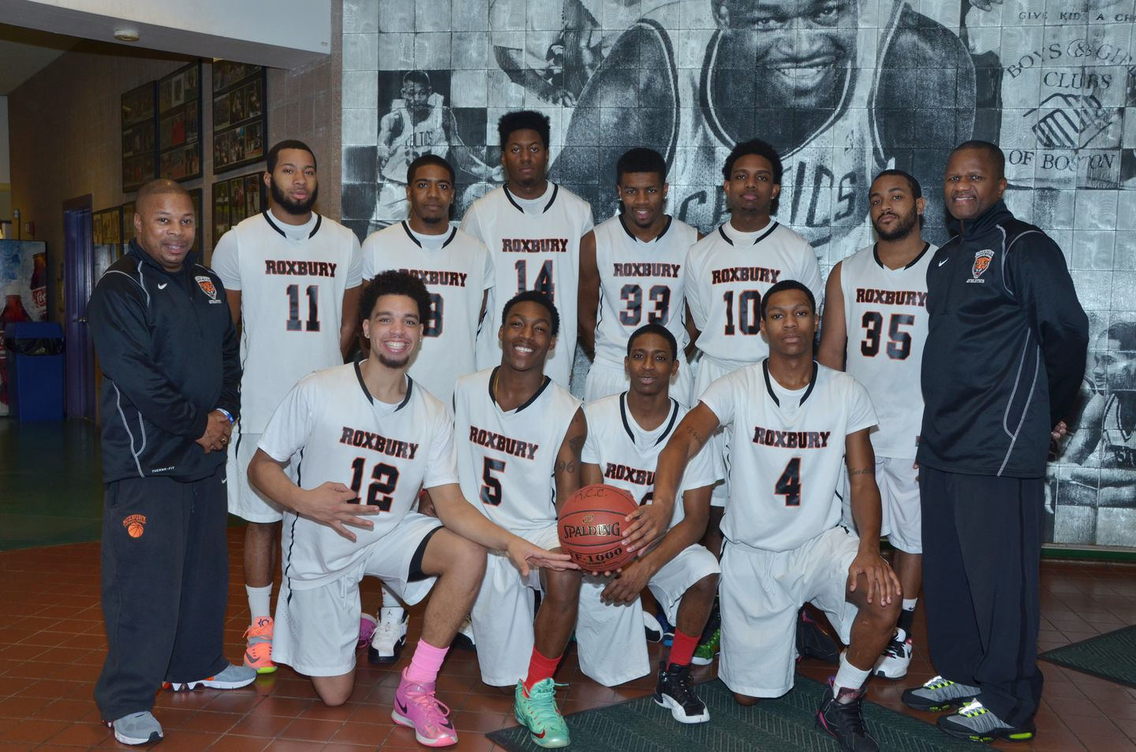The Roxbury Community College men’s basketball team at the start of the 2014-15 season. ROXBURY COMMUNITY COLLEGE



Plastic Surgeon's Guide To Filling In Eyebrows at Home (It's So Easy!)

Beverly Hills MD Learn More ›

It is late February and the Roxbury Community College men’s basketball team is minutes away from playing Bristol Community College in the first round of the National Junior College Athletic Association regional tournament.

Roxbury coach Kwami Green gathers his team for a pregame speech and urges each player to consider his mother.

“I want you to play as if someone is attacking her,’’ Green says. “You got to protect her.’’

Then Green writes a message on the board: “Play for Alex.”

Alex DoSouto was Roxbury’s starting guard until he was fatally shot the month before.

Another Roxbury guard walks to the board and writes, “Play for Kris Cook.”

Advertisement

# BOSTON GLOBE VIDEO



2:23

Baker announces ‘VaxM SHARE

Cook played for Roxbury in 2013 and 2014, before he was shot to death last December.

The moment underscored the important personal connections sports at the state’s community colleges can provide. Roxbury players and others like them across Massachusetts embody the hopes of struggling student-athletes pursuing their last chance of a college education.



Governor Charlie Baker announced residents who are

fully vaccinated against COVID-19 will have the chance to win $1 million in a special Lottery sweepstakes. (Photo by Matt Stone/Boston Herald via AP)

**s ns’**

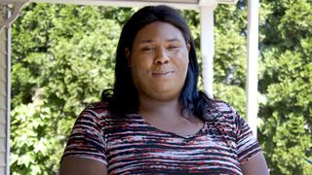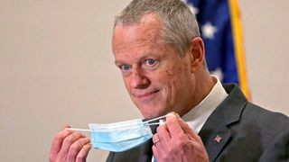

**Baker Moose What announce spotted Black ‘VaxMillio on liberation lottery Route 3 means program in to me:**

**Chelmsfo Athena**

**Vaughn**

**NOW PLAYING**

Get Sports Headlines in your inbox

**rd**

The Globe's most recent sports headlines delivered to your inbox every morning.

Enter Email

[example@email.com](mailto:example@email.com)

**Sign Up**

For decades, the state’s community college system has helped save legions of vulnerable young men and women from the dangers of the streets and the limitations of life without higher education.

Now, community college sports in Massachusetts may themselves be at risk. Squeezed by budget concerns and the public’s generally negative perception of the potential value, six of the state’s community college’s already have eliminated their athletic programs.

“With the difficulties in the economy that we’re starting to see more and more, it’s definitely a concern with the schools that are currently active,” said Khari Roulhac, the president of the Massachusetts Community College Athletic Conference.

Roulhac can remember a time when all 15 community colleges in the state had athletic programs. But Greenfield CC, Cape Cod CC, Middlesex CC, Mount Wachusett CC, North Shore CC and Berkshire CC have all been forced to cut their teams.

**MOST POPULAR ON BOSTONGLOBE.COM**

1. Message in a bottle, tossed into the sea in Rhode Island, found in Azores
2. Lawmakers reach compromise on restoring pandemic era-policies including to-go cocktails, outdoor dining
3. 5 things to know about the VaxMillions lottery sweepstakes in Mass.
4. Death penalty should be reinstated for Tsarnaev in Boston Marathon bombings case, Biden administration tells Supreme Court
5. Baker announces ‘VaxMillions’ lottery program, offering $1 million cash prizes to boost vaccination rates
6. America's blind spot: Thousands of drivers shouldn't be licensed
7. ‘People are awesome’: Dog rescued from White Mountains
8. A sordid family affair
9. How white supremacy weaponizes ignorance
10. Life sciences is poised to be Boston’s dominant industry. Has the area become the Silicon Valley of biotech?

Advertisement



**Code, experiment, and build your next great app using 12 months of free services**

**Try Azure free** >

Roulhac and athletic directors around the state fear that list will soon grow.

“There is always a threat that athletics could go the way of the dinosaur,” says Bill Raynor, athletic director at Massachusetts Bay Community College.

As tuition costs at four-year schools skyrocket and the chances of securing Division 1 athletic scholarships remain remote, community colleges offer students an affordable two years to improve their academics and athletics and apply for scholarships and other financial aid to continue their higher education.



ad exit

DOUBLE **DOWN**

**Get Started** The Citi®

Double Cash Card

For some players – those without resources, a supportive family, and a safe environment – those two years can make all the difference.

Mark Leszcyk, 51, who has guided the Roxbury women’s basketball team to three national championship games, cites the Stewart twins, Amanda and Alyssa, who bounced among four different foster homes before they landed at community college.

He also notes the success of Tyler Parker-Kimball, an All-American at Roxbury, who now is pursuing a master’s degree at Northeastern University.

“I always tell my girls, it’s not the hand you’re dealt that matters, it’s how you choose to play the cards,” Leszczyk says. “A lot of them are given bad hands.”

The financial feasibility of community college ranks among its greatest appeals. Tuition for one semester at Roxbury Community College costs

$3,912, compared to $27,293 at a private, non-profit four-year school, according to the College Board Advocacy and Policy Center.



**VIEWS FROM OUR COLUMNISTS**

**YVONNE ABRAHAM**

Energy efficiency is a low- hanging fruit to combat climate change. So why can’t everyone get access to it?

**KEVIN CULLEN**

Bill Bratton on American policing and the challenge facing the Boston Police Department

**THOMAS FARRAGHER**

A salute across the ages to an old squad leader

**SHIRLEY LEUNG**

A working mother’s manifesto: Pandemic provides a once-in-a- generation chance to course correct how we work

**JENEÉ OSTERHELDT**

Juneteenth and the meaning of Black liberation in Boston

**ADRIAN WALKER**

‘The best Boston movie no one’s ever seen’: ‘Blue Hill Avenue’ at 20

“You can look at the glass half empty or half full, but if you are not getting a scholarship to some private university, the best way to go is this way,” Green says. “Somebody who needs as much help as possible could get it at Roxbury.”

Advertisement



Roulhac said until people realize the potential value, the athletic will always be at risk.

“There’s got to be a value change to people throughout the commonwealth, including the legislature,” Roulhac said. “They need to recognize the value and the demographic that needs athletics. That it has proven to attract these students and keep them on the right path.”

Over the past 10 years, the MassBay men’s basketball team has helped 39 of 87 players earn associate degrees from the school. Eleven other players have transferred to four-year institutions.



At Roxbury, the women’s basketball program has sent 22 players to four- year universities since 2008, while 11 players from the men’s program have transferred to four-year institutions.

UMass Amherst gives preference to prospective transfers from all community colleges in the state with excellent academic records, through the “MassTransfer” program. Notable among those who have benefited is Paris Amado, once an at-risk high school student.

Amado was a senior guard at Quincy High School in 2008 when he was charged with possession and distribution of a class B and D substance. He said the school suspended him from September to December and called him a “detriment to society.”

After missing four months of school, Amado thought he had run out of options. But he was not convicted of the charges, and his mother encouraged him to go back to high school.

Advertisement



“It was just a hard time in my life because I only had my mother in my corner at the time,” Amado says. “I just felt like it was over for me.”

Enter Green. The Roxbury coach invited Amado to continue playing the game he loves and further his education. Amado attended mandatory study halls at Roxbury three days a week. He completed his two-year program with a GPA higher than 3.0 and was named to the NJCAA All-Academic team.

His performance at Roxbury catapulted him to UMass Amherst, where he received a bachelor’s degree in sociology in 2013. He now works at the Washington Urban Middle School in Roslindale as a behavior specialist, trying to prevent others from faltering in high school.

“I don’t know if I would be in the streets, locked up or dead [if not for attending Roxbury]”, Amado says. “With the road I was going on, community college was the perfect place for me to go.’’

For DoSouto, who grew up in Dorchester’s volatile Bowdoin-Geneva neighborhood, the road to Roxbury Community College began after he transitioned out of gang life, survived a shooting, and managed to earn a diploma from Boston English High School.

A city All-Star, he had received offers to play small-college basketball, but his career was cut short when he was convicted in 2009 of committing a felony in his prior gang life. Rather than leave Dorchester for college, he began a two-year prison sentence for an armed robbery in Quincy.

Advertisement



After prison, DoSouto connected with Roxbury’s assistant coach, Claude Pritchard. Pritchard and Green gave DoSouto a second chance, and he embraced it.

His sister, Christina DoSouto, said Alex saw college as a way to pursue his passion for basketball and rise above the violence that had claimed so many of his friends.

“He wanted to make us a proud,” she says.

On Jan. 8, he became Boston’s first homicide victim of 2015.

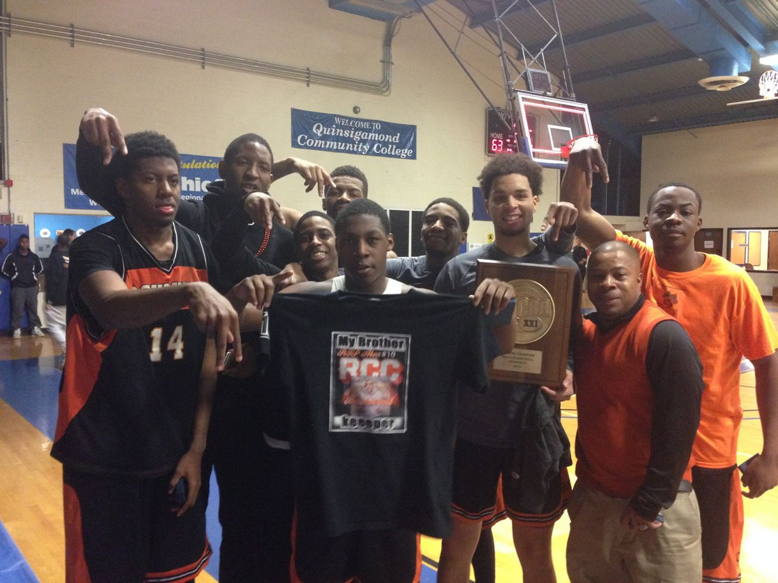

The Roxbury men’s basketball team showed off its t-shirts in memory of teammate Alex DoSouto after Roxbury won a regional tournament. ROXBURY COMMUNITY COLLEGE

DoSouto was not the only community college player who has fallen to the violence he strived to escape. Cook’s former girlfriend, Mariana Avila, said he grew up hard in San Diego, selling drugs and hanging with a dangerous crowd.

Cook fared well for a year at Roxbury before he returned home to recuperate from a knee injury.

“When he came [to RCC], he was away from home, away from all the BS, so all he had to focus on was school and basketball,” Avila says. “When he went back, it was back to square one.”

Cook was visiting a cousin in Arkansas last December when an intruder shot and killed him. He was 22.

“His goal was to go to a four-year college,” says Charlie Nedd-Araujo, an RCC basketball player who recently finished his two years at the college and plans to transfer to a four-year school.

The Stewart twins harbor similar aspirations. Like DoSouto and Cook, they endured difficult childhoods. They say their mother was immersed in Hartford street life, amid drugs and violence, as they bounced from foster home to foster home.

“That’s what the streets can do to you,” Alyssa says. “The streets can take you in and there’s no coming back sometimes.”

Without their mother’s blessing, the twins applied to RCC. “We just didn’t want to be in the same situation we were in,” Alyssa says.

The twins are banking on college basketball serving as a springboard to a better life, which pleases advocates of strong community college systems. Students committed to staying academically eligible for athletics often perform better in the classroom.

“We should be looking for every conceivable way to connect with these kids and motivate them to stay in school,” says former Massachusetts governor Michael Dukakis, who teaches political science at Northeastern and the University of California at Los Angeles.

Improving the public’s perception of community colleges would help, says MassBay’s Raynor.

“We look at community colleges in the east as dumping grounds for the underachiever,” Raynor says. “If we can begin to change that perception and have not just students but parents take advantage of this option it would serve them well.”

For some, community college is a lifesaver – if only for too short a time. On Mariana Avila’s last visit with Cook in San Diego, she remembers him repeatedly expressing his eagerness to return to Roxbury and embrace his second chance.

“Honestly, if it wasn’t for RCC I don’t know what I would be doing with myself right now,” she remembers him saying.

Follow Zolan Kanno-Youngs on Twitter at @kannoyoungs.

**Show comments**

**MORE ON GLOBE.COM**

# SPONSORED BY: PHILIP MORRIS INTERNATIONAL

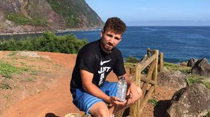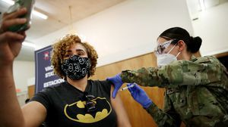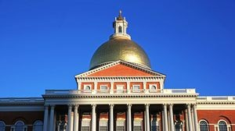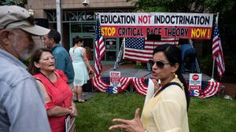

## Remote health care could be — and should be — here to stay

In response to the pandemic, insurers expanded coverage for virtual health services. How long will it last?

# RI NEWS

## Message in a bottle, tossed into the sea in Rhode Island, found in Azores

The note was written in 2018 by a 13- year-old who was visiting family in Rhode Island.

**America's blind spot: Thousands of drivers shouldn't be licensed** A Boston Globe investigation of how bureaucratic negligence has left lethal drivers on the road.

## 5 things to know about the VaxMillions lottery sweepstakes in Mass.

Here are five things you should know about the VaxMillions program, which will make some lucky winners living proof that trusting the science really does pay.

## Lawmakers reach compromise on restoring pandemic era- policies including to-go cocktails, outdoor dining

A House and Senate conference committee has reached a compromise to extend several pandemic-era policies that expired earlier in the day, legislative leaders said Tuesday night.

# OPINION

## How white supremacy weaponizes ignorance

Racists have always understood that if they can censor what people learn, they can control what people believe.

## A treasure map for an American tyrant

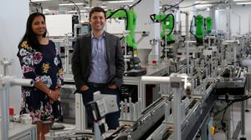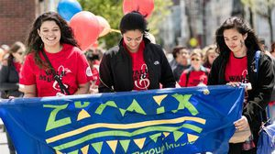

Donald Trump exposed weaknesses that a would-be dictator could exploit to end our democracy. It’s now up to lawmakers, voters, and public officials to prevent that from happening.

## Death penalty should be reinstated for Tsarnaev in Boston Marathon bombings case, Biden administration tells Supreme Court

The Biden administration is asking the Supreme Court to reinstate the death penalty against Dzhokhar Tsarnaev for the Boston Marathon terror bombings.

# INNOVATION ECONOMY

## Life sciences is poised to be Boston’s dominant industry. Has the area become the Silicon Valley of biotech?

Since December, you can find six major indications that Boston is the undisputed center of the life sciences industry, a place where ideas and products that change ― and save ― people’s lives around the world originate.

## These Massachusetts organizations received donations from MacKenzie Scott

A number of Massachusetts organizations received millions of dollars in donations as part of Mackenzie Scott’s latest, $2.7 billion round of philanthropic gifts.

**MOST READ IN THIS SECTION**

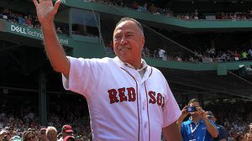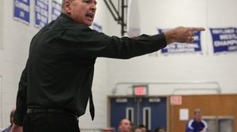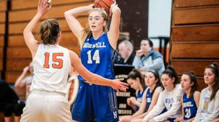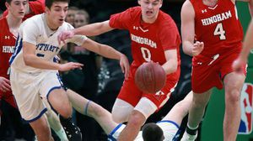

**SPORTS MEDIA**

**NESN’s Jerry Remy ‘doing much better’ after leaving Friday’s Red Sox broadcast and being admitted to hospital**

**Patriots’ Dont’a Hightower is at minicamp to play football, and he can’t be any clearer**

**TARA SULLIVAN**

**French Open triumph may signal that Novak Djokovic is the best of them all, and other thoughts**

**ON BASEBALL**

**Are the Red Sox’ pitching struggles a sticky mess? The data say ...**

**Oliver Ames boys’ basketball coach Don Byron dies of cancer at age 68**

**HIGH SCHOOL GIRLS’ BASKETBALL NOTES**

**After her vision was imperiled by a tumor, Norwell’s Caroline Kenney never lost sight of her goal to return to the court**

**MINOR LEAGUE NOTEBOOK**

**Opportunities await Red Sox righthander Tanner Houck upon his return to health**

**Sepp Blatter showered with fake money at FIFA news conference**

**HIGH SCHOOL NOTEBOOK**

**Auerbach track meets offer glimpse of the future**

# FOLLOW US

**SUBSCRIBE NOW MY ACCOUNT CONTACT MORE**

Digital Access Home Delivery Gift Subscriptions

Log In

Manage My Account Customer Service

Help & FAQs Globe Newsroom Advertise

Newsletters / View The EPaper /

Order Back Issues / News In Education / Search The Archives / Privacy Policy / Terms Of Service / Terms Of Purchase / Work At Boston Globe Media /

Do Not Sell My Personal Information

**METRO SPORTS BUSINESS & TECH OPINION**

WELCOME, JOHN

**TODAY'S PAPER**

**Check out this week's virtual events**

RSVP now

**LAWMAKERS STRIKE DEAL TO RESTORE PANDEMIC-ERA POLICIES, INCLUDING EVICTION PROTECTIONS, TO-GO COCKTAILS**



©2021 Boston Globe Media Partners, LLC